Random variables

Discrete random variable:can take finite or countably infinite no of values

Random variables
They are not like traditional var that we are first exposed in algebra class.
Random variables are ways to map to map outcomes of random processes to numbers.So you are quantifying the outcomes.
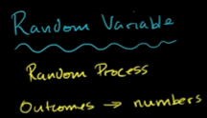
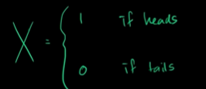

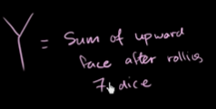

Why we wanna do this?
As soon as we quantify outcomes, we can start doing a little math on the outcomes and start to use a mathematical notation on the outcome.
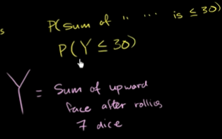

Discrete and continious random variables
Discrete random variables these are variables which can take distinct or seperate values.

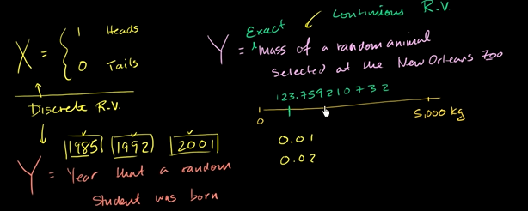
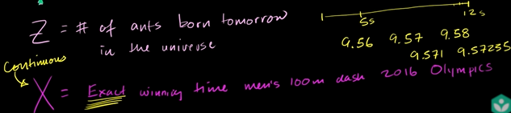
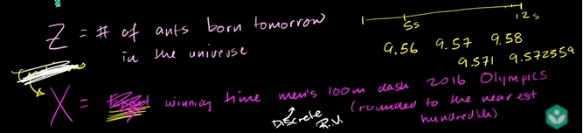

Constructing a probability distribution for random variable
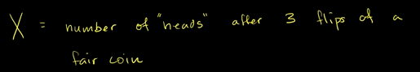

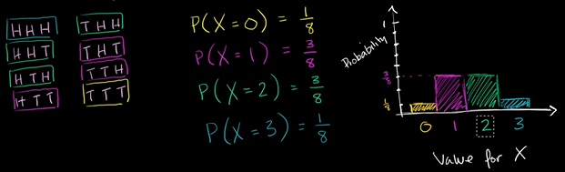

Discrete proabability distribution for X.

Probability models example : frozen yogurt
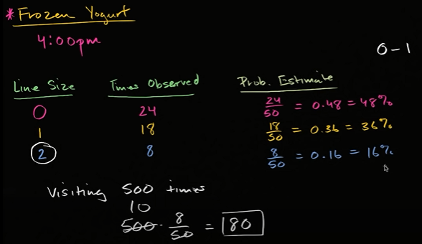

Probability with discrete random variable example
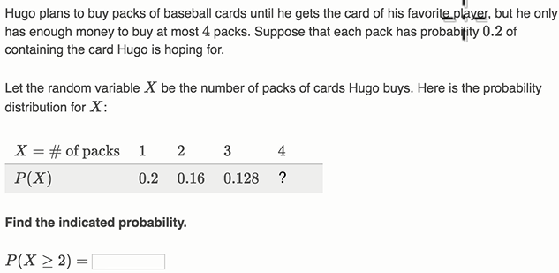

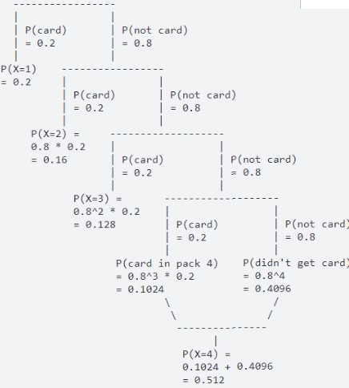

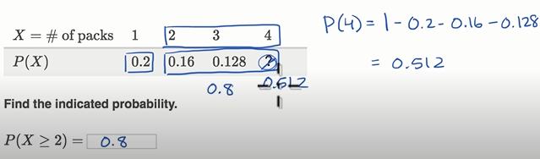

Mean ( Expected value ) of a discrete random variable
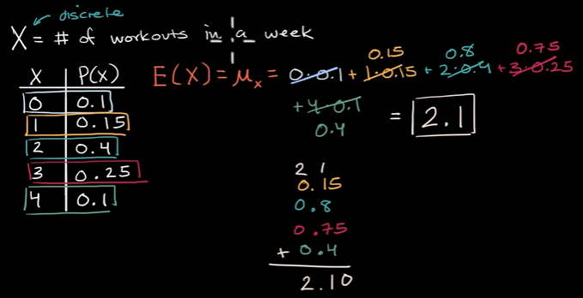
All the outcomes here are whole numbers, how can u have 2.1 workouts in a week.
Its like in 10 weeks , u will do 21 workouts.
Sometimes I would do 0,1,2,3,4 workouts .
But in 100 weeks, u might expect me to do 210 workouts.
So even for random variable, which u can only take on integer values you can still have non – integer expected value.
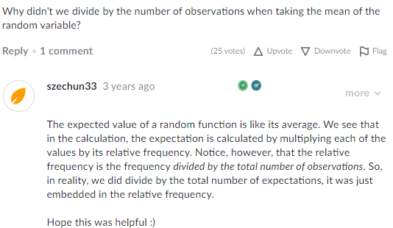

Variance and Standard deviation of a discrete random variable
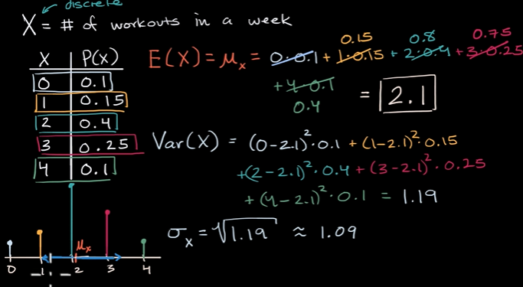

Probability density functions
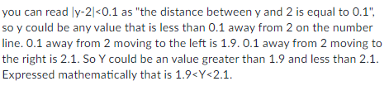

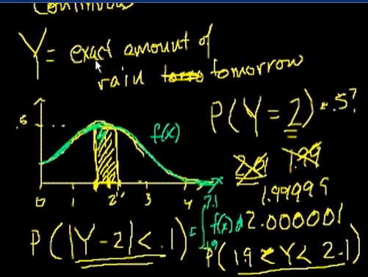

Probabilities from density curves
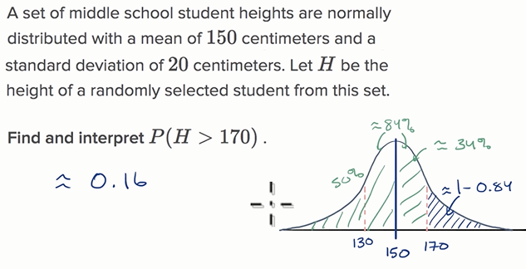

Impact of transforming ( scaling and shifting ) random variables
How is the mean, S.D affected , if we were to add to this random variable or if we were to scale this random variable.
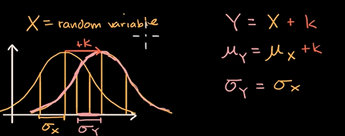

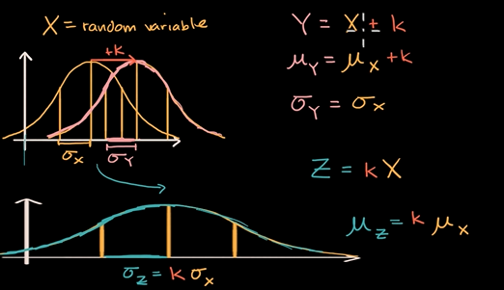

Transforming a discrete random variable
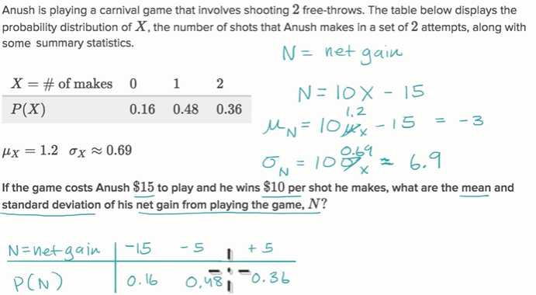

Combining random variable

Mean of sum and difference of random variable
E(X+Y) I.e mean of the sum of these two random variables.
What is the expected number of dogs and cats that I would see in a given day.
E(Y-X) I.e how many more cats in a given day I expect to see than dogs.
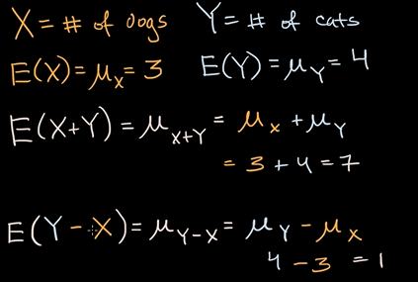
Mean of the sum is the same as sum of means and the mean of difference of random variable is the same as the difference of the mean.

Variance of sum and difference of random variables
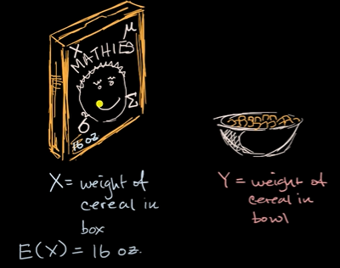
When you see net weight 16oz , it doesn’t mean every box is gonna wiegh 16 ounce.
You have discrete #no of flakes, they have slightly different density, slightly different shape.

There is some variation, that you can measure with standard deviation.
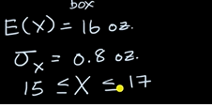
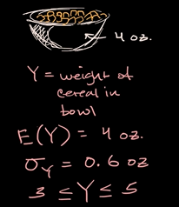

X is some random box and Y is random filled bowl.

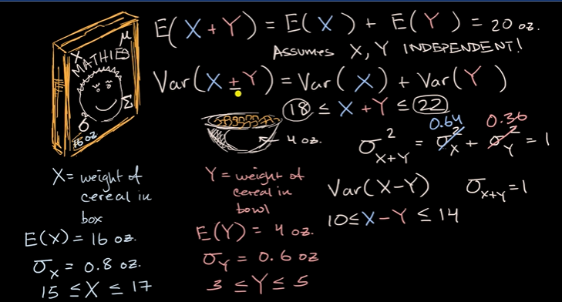
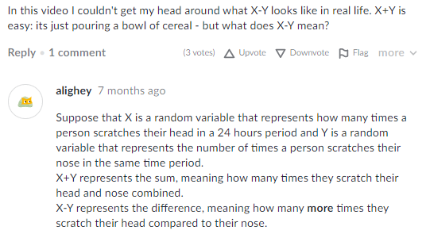

Intuition for why independence matter for variance of sum
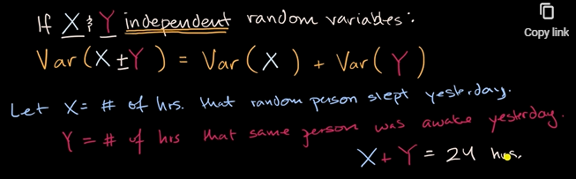
Both X and Y are random variables, they are definitely not independent.
So if x is 8 then y is 24-8=16
If u know one of the variable, you can determine what the other variable is.
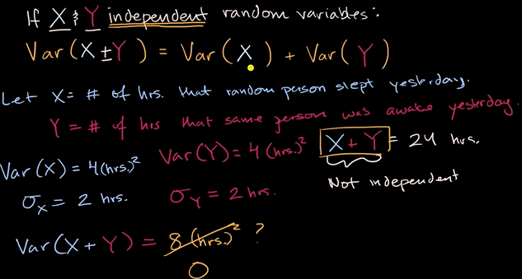
Im confused still too.

Deriving the variance of the difference of random variable
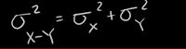
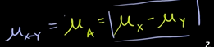

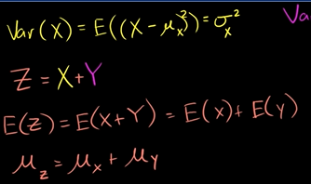

Example: Analyzing distribution of sum of two normally distributed random variables
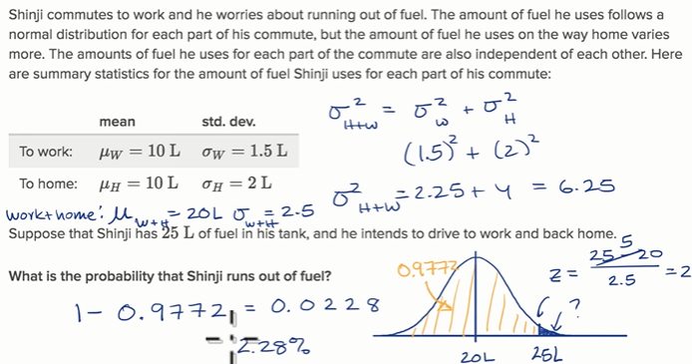

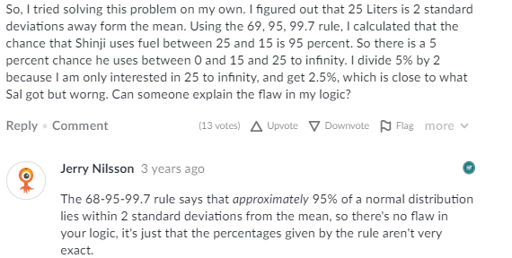

Analyzing the difference in distributions
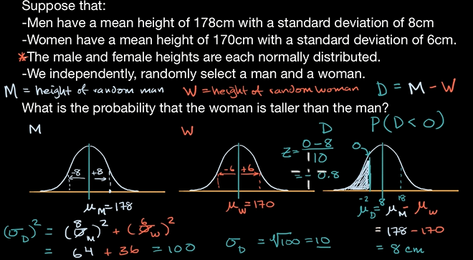
You can use Z-table or you can use a graphing calculator, TI85, where you have normal cumulative distribution function.
He teach here how to use.
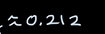

Binomial random variables

Binomial variables
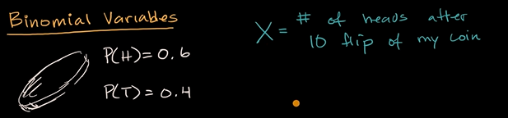
What makes it a binomial variables?
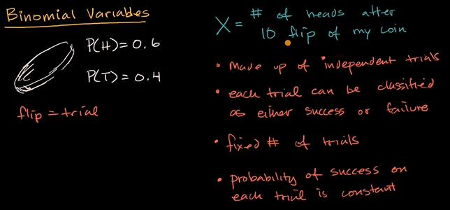
What is not a binomial variables?
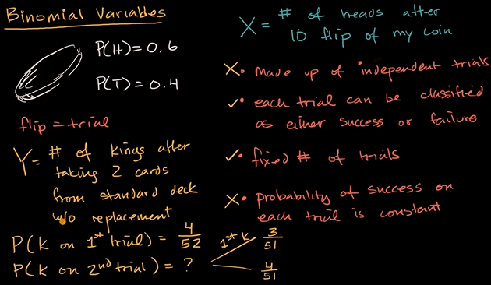

What happen when we change the question a bit?
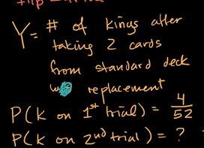
This will be a binomial variable.

Recognizing binomial variables
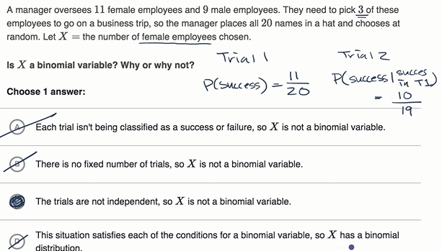
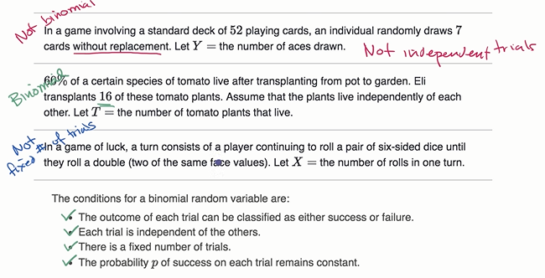

10% Rule of assuming “independence” between trials.
Normal distribution or binomial distribution, they can be viewed as the sum of bunch of independent trials.


Let say you doing a survey on people exiting the mall, you are saying whether they have done their taxes already.
If they are exiting the mall, its hard to do these samples with replacement.
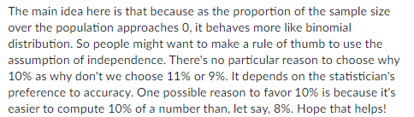

If you have 10k ppl in the mall, does it really matter, whether its truly independent.
Because we wanna make inferences when close to normal distribution or binomial distribution.
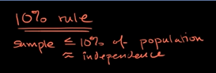

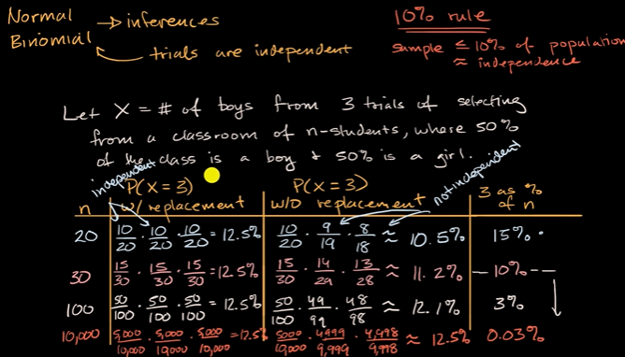

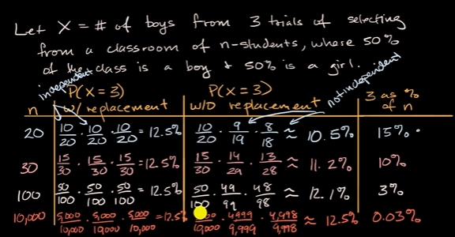
For sample size 20, we see The probability(x=3) w/o replacement is giving 16% different in terms of proabability relative to with replacement.
As we see the sample size increases, the proabability without replacement becomes very close.
So where to draw threshold is at 10%.
So if your sample size is below and equal to 10% of population, you can treat them as independent variable and perform inferences.

Binomial distribution
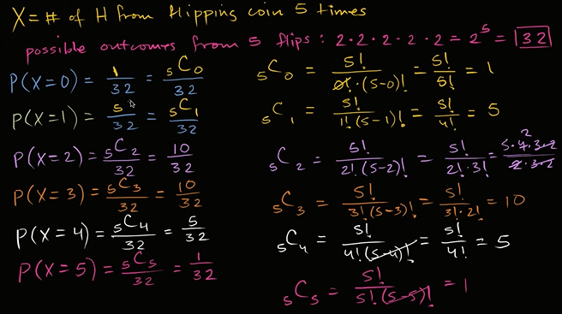

Visualizing a binomial distribution
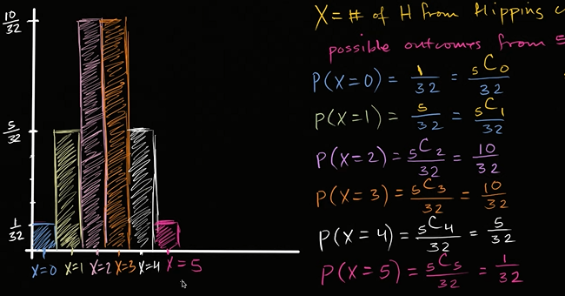
This symmertry, discrete distribution like this , is called binomial distribution.
Its called binomial distribution, bcoz this properties you can get using binomial distribution or using combinatorics.

IF x was 5 million Heads instead of 5 heads in 10 flips, the bar will get narrower and the shape will look like bell curve.
Bell curve is a normal distribution, is a pdf, its continious.
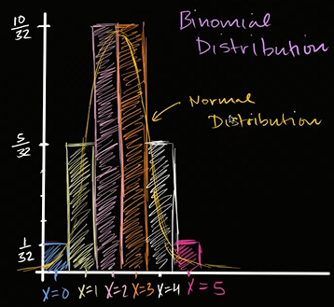

Binomial distribution is discrete version of Normal distribution.

Binomial proabability example
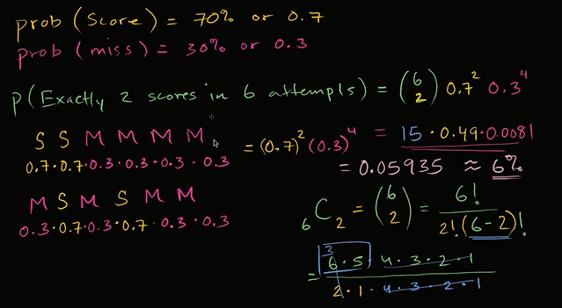

Generalizing k scores in n attemp
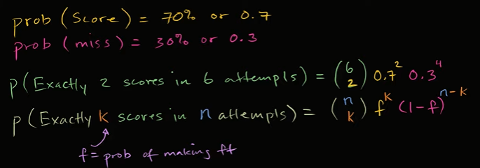

Free throw binomial probability distribution
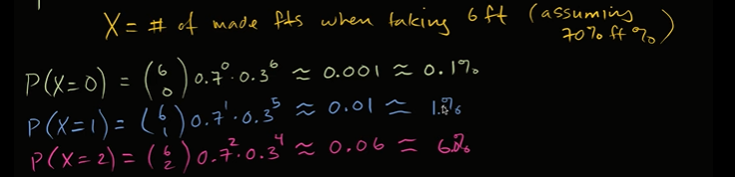
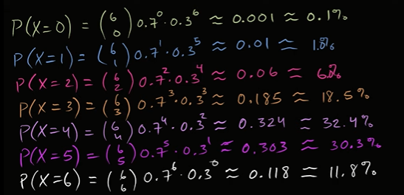

Well, you’ll say I don’t see the symmetry, thats bcoz u have 70% more likely to make a free throw than not.
Where you’ll see the symmetry is in the coefficient.
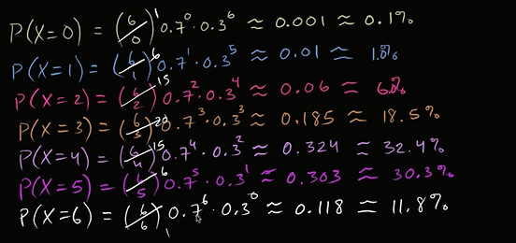

Graphing basketball binomial distribution
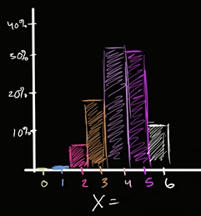

Binompdf and binomcdf functions
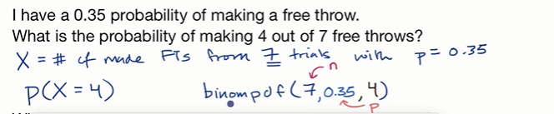
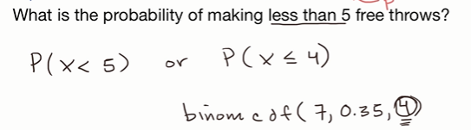

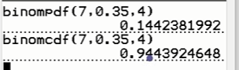

Binomial mean and standard deviation formulas

Mean and variance of bernouli distribution example
So, if I approach every person in the population, ask them about our president, they will either have a favourable or unfavourable rating.
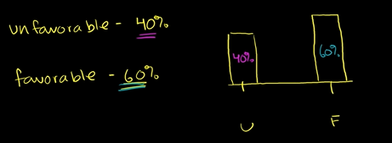

if we ask a random person from the population and say what is the expected favourability rating of that member what would it be?
Another way to think about, what is the mean of the distribution?
For a discrete distribution like this, your mean or your expected value is just going to be the proabability wieghted sum of the different values that your distribution can take on.
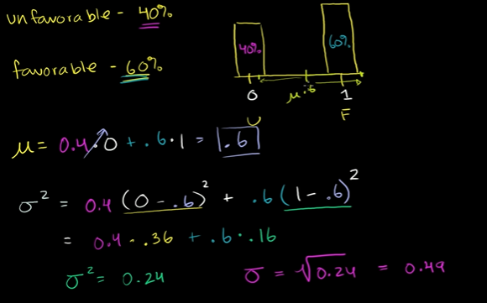

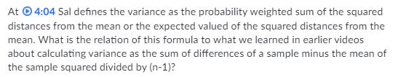

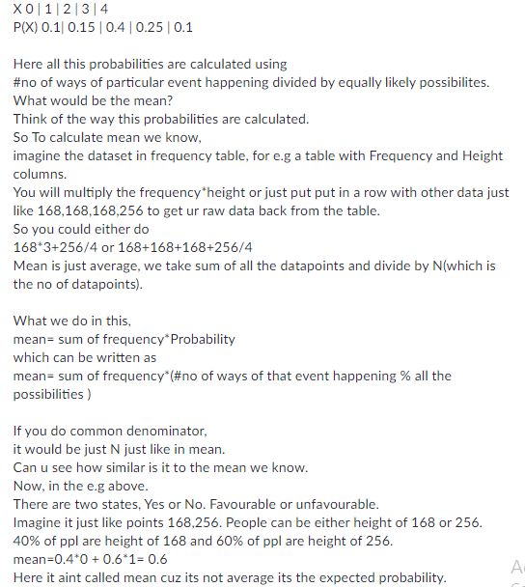

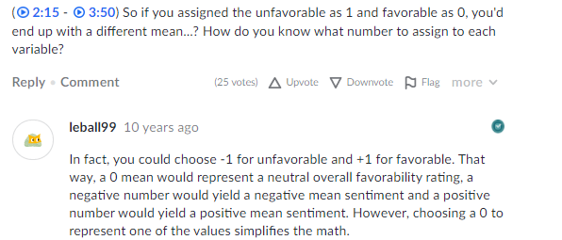
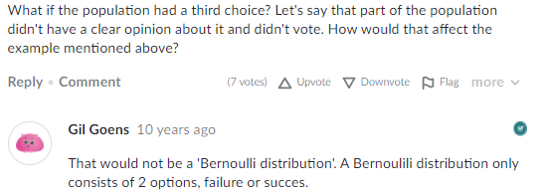
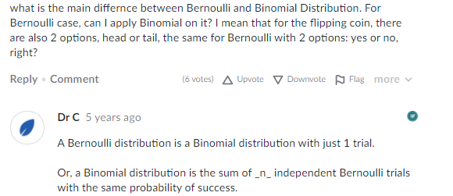

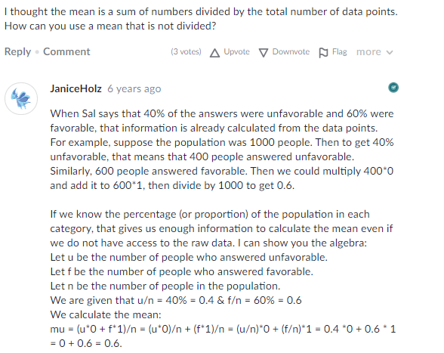

Bernoulli distribution mean and variance formula
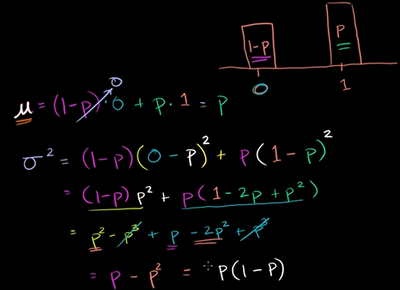

Expected value of a binomial variable Pending
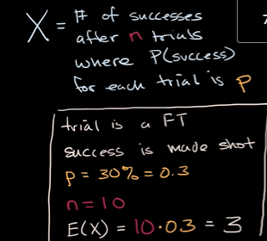

Variance of a binomial variable
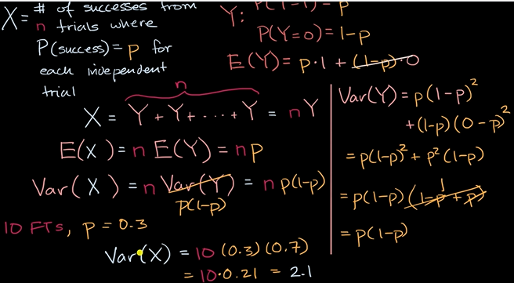

Finding the mean and S.D of a binomial random variable
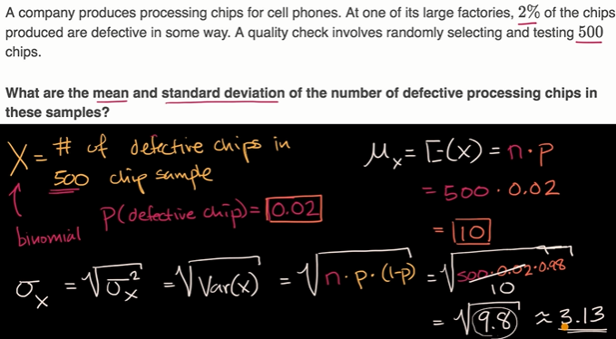

Geometric Random variables

Geometric Random variables introduction
Distinguishing between Geometric and binomial random variables.
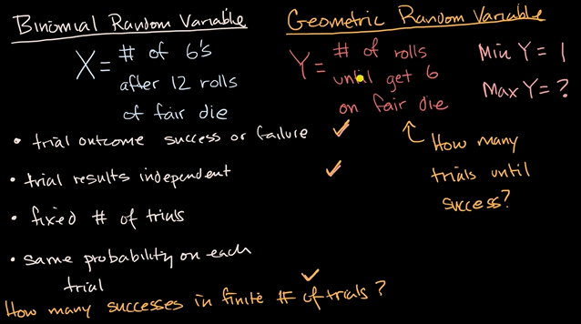
It is called geometric, cuz the maths that involves the proabability of various outcomes, looks a lot like geometric growth or geometric sequences or series.
We called binomial random variables, bcoz when we think about probabilities of different outcomes, u have binomial coefficients based on combinatorics.

Probability for a geometric random variable
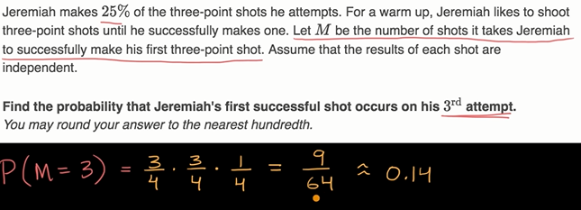

Cumulative geometric probability
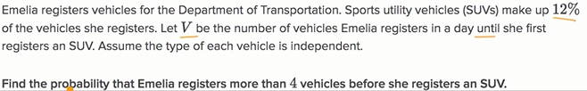
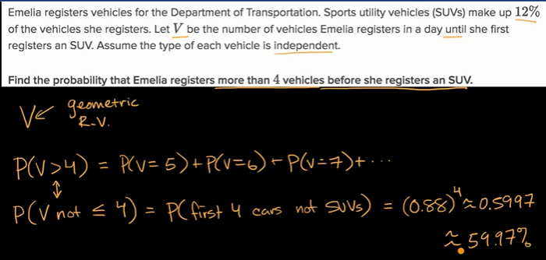
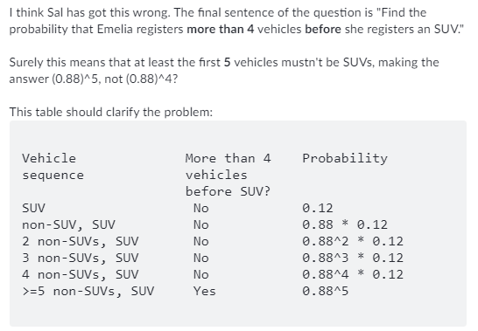

Cumulative geometric probability ( less than a vale)
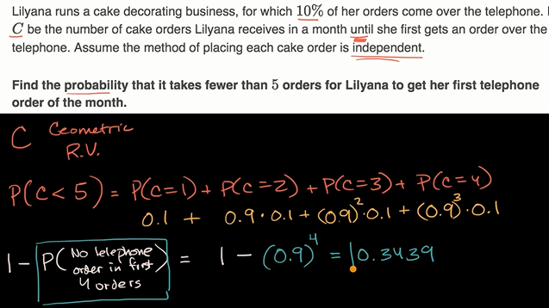

TI-84 geometpdf and geometcdf func
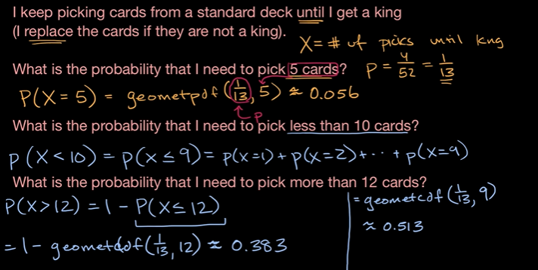
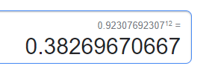

proof of expected value of geometric random variable
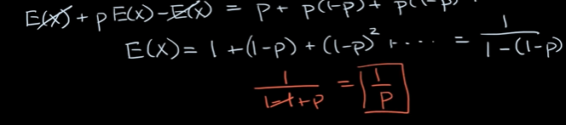
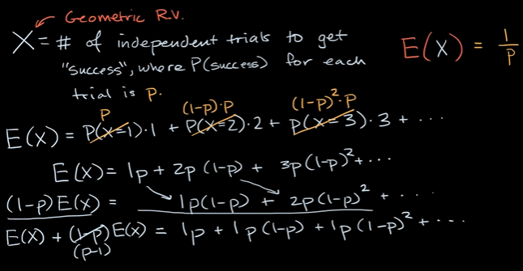

More on Expected value

Term life insurance and death probability


Term life policy, which is I just care about the next 20 years, after those 20yr I can hopefully pay off my mortgage.
Whole life policy: you could pay a certain amount per year for rest of your life, any point you die, you get the million dollars.
In term life, im only going to pay a 500$ per year for the next 20 years. At any point I die, my family gets a one million.
At 21st year I need to get a new policy and I have a higher chance of dying at that point, then its probably be more expensive for me to get insurance.
But I really am just worried about the next 20 year.
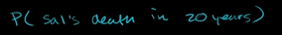
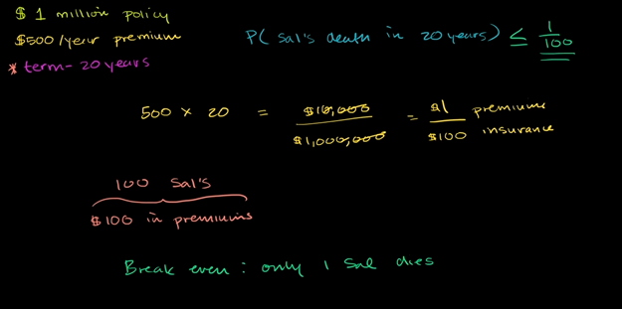

Getting data from expected value
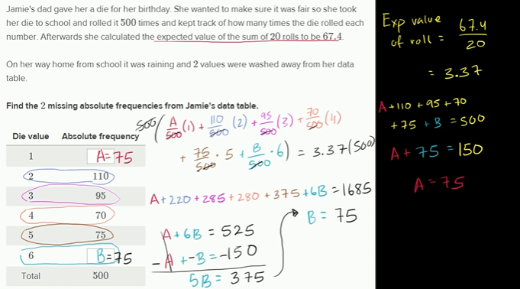
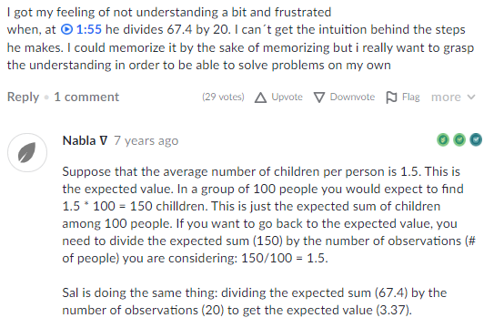

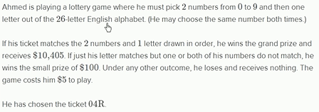
Expected profit from lottery ticket

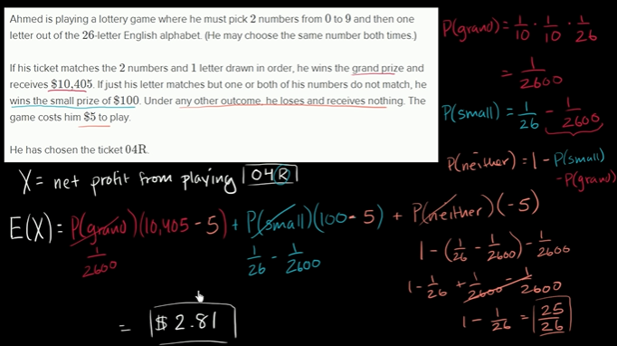

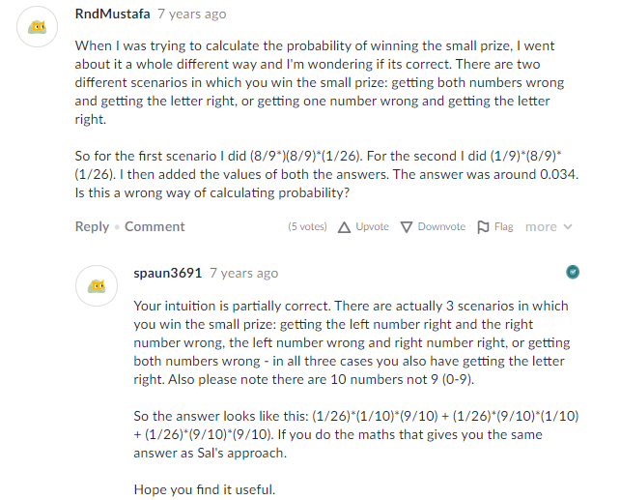

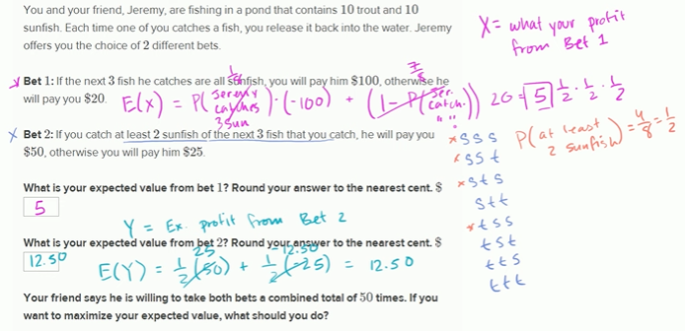


Comparing insurance with expected value
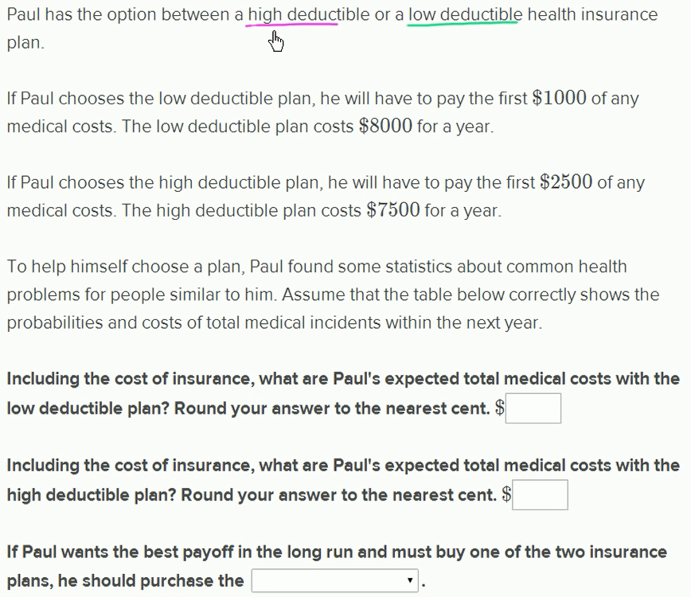

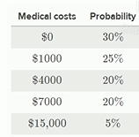

When we talk about deductible in health insurance plan, if some1 says they have a plan with $1000 deductible. That means that the insurance company only pays the medical cost after the first $1000. So if you say u have $1000 deductible and u say, incur medical cost of $800. You gonna pay $800 , the insurance company wont pay anything. If you have a deductible of $1000 and your total medical cost are $1200. You gonna pay $1000 and the insurance company would kick in after that.
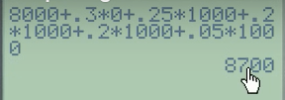


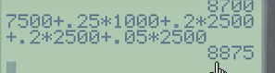



Law of large numbers
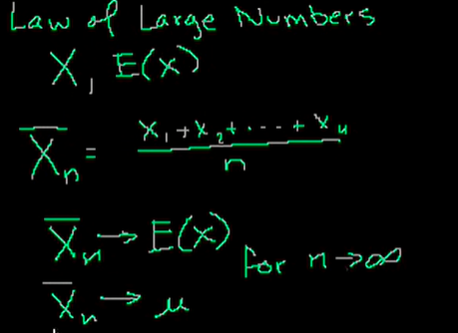
Given x, expected value

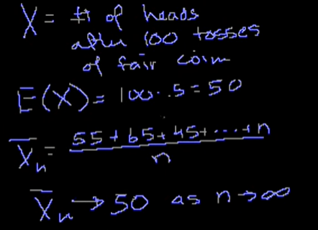

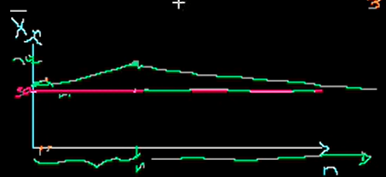
Thats what happen at lottery, casino. If they do large enough sample, even if things deviate significantly, the casino and lottery operates on the principle.
Even if in short term, couple people beat the house, but in long term the house is always gonna win. Bcoz of the parameters of the game being played.

Poisson distribution

Poisson process 1
Traffic engineer, how many car pass by at certain point on the street at any given point in time.
Once you know the probabilities distribution you can ans what is the probabilities that 100 cars pass in a hour.
Two assumptions cuz we gonna study poisson distribution.
1. Any hour in a street is no any different than any other hour. Within hour there is no differentiation from one sec to another in terms of probabilities that car arrives.
2. If bunch of cars passes within one hour, it doesn’t mean fewer cars will pass in next.
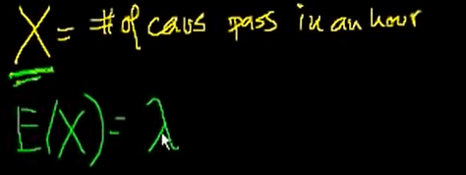

pENDING

